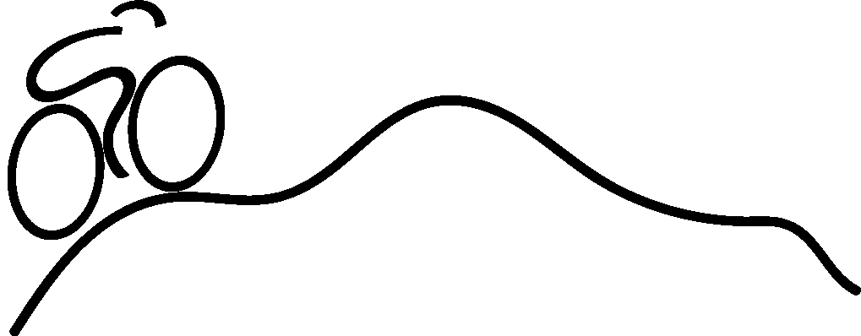
WELCOME! Thank you for choosing to participate in the 100K ride for the 25th annual Bike Shenandoah event this year.
Start time: 7:30 am, Saturday September 17th, 2022
● Please arrive by 7:00 am to check in
● Give yourself 15 minutes or so of easy spinning to warm up
Start Location: EMS parking lot - 801 Parkwood Dr., Harrisonburg, VA, 22802.
Directions:
● Riders will leave as a group promptly at start time.
● Use proper hand signals and obey the rules of the road.
● Use the bike lane when available.
● Ride single file mostly, definitely no more than 2 riders side by side.
● Give plenty of room to the riders next to you to avoid crashes.
● Ride at your own pace - a pace that is comfortable for you.
● Having riding partners choosing to work together at a similar pace will make the ride easier, provide opportunity to get acquainted with fellow riders and create an enjoyable day while cycling for service.
Ride Markers: Blue Dot
● The route is marked with a Blue Dot. The White dot is your reference point.
● Turn right: If the Blue dot is to the right of the White dot. Turn left: If the Blue dot is left of the White dot.
● Continue Straight: The Blue dot is above the White dot.
● Other dots: This route is also used for other rides so you will see dots of other colors.
● If you find markings are confusing or you see a discrepancy with the cue sheet, follow the cue sheet.
● There may be other cycling event routes marked on some of the roads we are using; follow the Blue Dot!
● * There is one place that uses the same intersection twice. Continue going the same compass direction through the intersection both times. The second time while traveling north, there is a stop sign, left turn, then an immediate right turn to continue going north.
Notices:
● There may be some heavy traffic along the route. Please watch for vehicles and follow all road rules.
● The route has hill climbs. Be sure to stay hydrated!
● The best strategies to avoid suffering from cramped muscles are adequate hydration, eating bananas, avoiding pushing hard in big gears and keeping a pace similar to or less than your training pace.
Rest Stops:
● The route has 2 rest stops. (approx. mile 22.1 and mile 47.4)
● There will be a REST STOP poster and road markings at your two rest stops .
● Be sure to fill water bottles at each rest stop and stay hydrated.
● If you are wearing an extra jacket, leg warmers, etc., you will have an opportunity to place them in a bag at the 1st rest stop where they will be picked up by a SAG vehicle and taken to the registration desk.
● Be sure to claim your items at the end of the ride.
● If you decide to abandon the ride or change to a different route, please call to report your plans.
SAG: (Supplies And Gear)
● You will see a SAG support vehicle from time to time. The vehicle will have a sign in the window and is available to provide assistance if you need it.
● The signal for having them stop is this: Place your hand on top of your helmet and raise your hand twice. This will avoid confusion for the driver when riders give a friendly wave and so forth.

After the ride:
Important: Please check in at the registration desk when you finish so we can mark you as safely returned.
Please plan to return to EMS no later than 2pm.

Lunch: provided free for riders (courtesy of our sponsors)
Hours: 11:30 am - 1:30 pm
Location: EMS dining hall
Please wear your mask indoors when not eating and physically distance when possible (families that live together feel free to sit together)
Stay safe and enjoy your ride!

