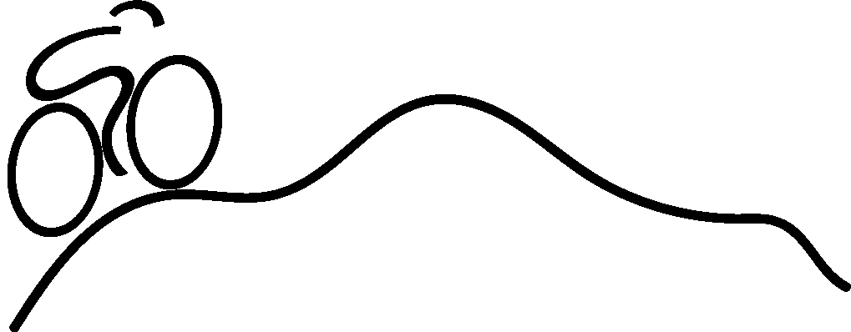
WELCOME! Thank you for choosing to participate in the 5K ride for the annual Bike Shenandoah event.
Start time: 11:00 am, Saturday September 16th, 2023
● Please arrive by 10:30 am to check in
● Give yourself 15 minutes or so of easy spinning to warm up
Start Location: EMS parking lot - 801 Parkwood Dr., Harrisonburg, VA, 22802.
Directions:
● Riders will leave as a group promptly at start time.
● Use proper hand signals and obey the rules of the road.
● Use the bike lane when available.
● Ride single file mostly, definitely no more than 2 riders side by side.
● Give plenty of room to the riders next to you to avoid crashes.
● Ride at your own pace - a pace that is comfortable for you.
Ride Markers: Red Dot
● The route is marked with a Red Dot
● The White dot is your reference point.
● Turn right: If the Red dot is to the right of the White dot.
● Turn left: If the Red dot is to the left of the White dot.
● Continue Straight: If the Red dot is above the White dot.
● Other dots: This route marking (using other colors) is used for other routes. e.g. the 25 K ride follows a Green dot.
● If you find markings are confusing or you see a discrepancy with the cue sheet, the cue sheet provided is the correct route to follow.
● There may be other event routes marked on some roads we are using. Be sure to follow the Bike Shenandoah Red Dot markings and not another route.
Notices:
● There may be heavy traffic where you cross Mt. Clinton Pike. Traffic marshals will assist you as needed.
● The route has a few hill climbs. Be prepared and use your lower gearing. Stay hydrated.

Minor Waiver Form:
If you are/have a minor, the signed minor waiver form MUST be given at check in to participate in the ride.

After the ride:
Important: Please check in at the registration desk when you finish so we can mark you as safely returned.
Please plan to return to EMS no later than 1pm.

Lunch: provided free for riders (courtesy of our sponsors)
Hours: 11:30 am - 1:30 pm
Location: EMS dining hall
Please wear your mask indoors when not eating and physically distance when possible (families that live together feel free to sit together)
Stay safe and enjoy your ride!

